AI-Lab 07 Submission
Name: Yash Raj
Roll Number: 24k-0737
Task 01:
from ortools.sat.python import cp_model

model = cp_model.CpModel()
nodes = ['A', 'B', 'C', 'D']
node_vars = {n: model.NewIntVar(0, 2, n) for n in nodes}

edges = [('A','B'), ('A','C'), ('B','C'), ('B','D'), ('C','D')]

for u, v in edges:
model.Add(node_vars[u] != node_vars[v])

solver = cp_model.CpSolver()

class SolutionPrinter(cp_model.CpSolverSolutionCallback):
def __init__(self, variables):
cp_model.CpSolverSolutionCallback.__init__(self)
self.variables = variables

def on_solution_callback(self):
print({v: self.Value(self.variables[v]) for v in self.variables})

solver.SearchForAllSolutions(model, SolutionPrinter(node_vars))
Output:
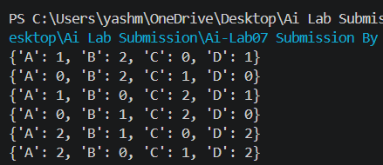
Task 02:
from ortools.sat.python import cp_model

model = cp_model.CpModel()

days = ["Mon", "Tue", "Wed", "Thu", "Fri"]

shirt = {d: model.NewIntVar(0, 4, f"shirt_{d}") for d in days}
pant = {d: model.NewIntVar(0, 2, f"pant_{d}") for d in days}
sq = {d: model.NewIntVar(0, 1, f"sq_{d}") for d in days}

use_sq = {d: model.NewBoolVar(f"use_sq_{d}") for d in days}

for d in days:
model.Add(use_sq[d] == 1).OnlyEnforceIf(use_sq[d])
model.Add(use_sq[d] == 0).OnlyEnforceIf(use_sq[d].Not())

model.Add(sq[d] >= 0).OnlyEnforceIf(use_sq[d])
model.Add(sq[d] == 0).OnlyEnforceIf(use_sq[d].Not())

model.Add(shirt[d] >= 0).OnlyEnforceIf(use_sq[d].Not())
model.Add(pant[d] >= 0).OnlyEnforceIf(use_sq[d].Not())

model.Add(use_sq["Fri"] == 1)

model.Add(use_sq["Mon"] == 0)
model.Add(use_sq["Thu"] == 0)

for d in days:
model.AddAllDifferent([shirt[d], pant[d], sq[d]])

model.AddAllDifferent(
[shirt[d] * 10 + pant[d] for d in days]
)

solver = cp_model.CpSolver()

status = solver.Solve(model)

if status in [cp_model.OPTIMAL, cp_model.FEASIBLE]:
for d in days:
if solver.Value(use_sq[d]) == 1:
print(d, "→ SQ", solver.Value(sq[d]))
else:
print(d, "→ Shirt", solver.Value(shirt[d]), ", Pant", solver.Value(pant[d]))
else:
print("No solution found")

Output:
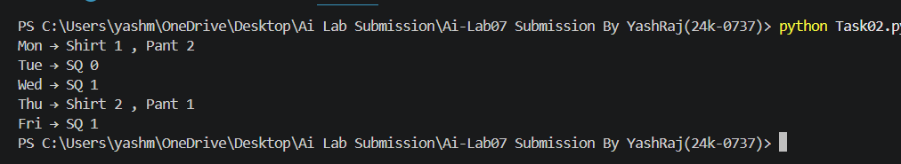

Task 03:
from ortools.sat.python import cp_model

model = cp_model.CpModel()

grid = {}
for i in range(9):
for j in range(9):
grid[(i, j)] = model.NewIntVar(1, 9, f'cell_{i}_{j}')

puzzle = [
[5,3,0,0,7,0,0,0,0],
[6,0,0,1,9,5,0,0,0],
[0,9,8,0,0,0,0,6,0],
[8,0,0,0,6,0,0,0,3],
[4,0,0,8,0,3,0,0,1],
[7,0,0,0,2,0,0,0,6],
[0,6,0,0,0,0,2,8,0],
[0,0,0,4,1,9,0,0,5],
[0,0,0,0,8,0,0,7,9]
]

for i in range(9):
for j in range(9):
if puzzle[i][j] != 0:
model.Add(grid[(i, j)] == puzzle[i][j])

for i in range(9):
model.AddAllDifferent([grid[(i, j)] for j in range(9)])

for j in range(9):
model.AddAllDifferent([grid[(i, j)] for i in range(9)])

for box_row in range(3):
for box_col in range(3):
cells = []
for i in range(3):
for j in range(3):
cells.append(grid[(box_row*3+i, box_col*3+j)])
model.AddAllDifferent(cells)

solver = cp_model.CpSolver()
status = solver.Solve(model)

if status == cp_model.FEASIBLE or status == cp_model.OPTIMAL:
for i in range(9):
print([solver.Value(grid[(i, j)]) for j in range(9)])

Output:
